Research article

STUDY OF THE TEMPERATURE DISTRIBUTION IN STEEL BASE HEATING DEVICE FOR BIORREACTORS, USING CAE SOFTWARE
Rodríguez Rodríguez Irving Iván*, Rodríguez Chávez Jorge Antonio, Hurtado Delgado Eduardo
¹ Departamento de Posgrado, Corporación Mexicana de Investigación en Materiales S.A de C.V., Ciencia y Tecnología No. 790, Saltillo 400, Saltillo, Coahuila.

*Corresponding author: ibqrodriguez10@outlook.es

Abstract.
Biochemical processes require controlled temperatures in isolated systems to increase reaction efficiency. In a bioreactor, the heating systems must be made of materials that allow rapid dissipation to the liquid substrate and, in addition, yield the appropriate amount of heat to maintain an optimum temperature for the reaction. In this work it is proposed to simulate the heat load obtained by a steel base heating device and its temperature distribution through the contact surface, using CAE software and compare with approximation to the analytical solution of the differential that explains the molding and propose Approach functions. For a stability time t = 2600s, the simulation in NX and COMSOL (11234891 nodes, 48.3 min; 145298, 63.2 min) respectively obtaining a value R² = 0.97 with respect to the real one. Methods of approximation to analytical solution and proposed functions R² = 0.93 and 0.92 respectively. Obtaining a satisfactory answer for the proposed solution methods. The temperature distribution will indicate the location of the device for uniform heating. The R² values ​​were ideal to be able to perform the evaluation using CAE software and evaluate the equilibrium conditions with the properties of a particular fluid.
Resumen..
Los procesos bioquímicos requieren de temperaturas controladas en sistemas aislados para aumentar en rendimiento de reacción. En un biorreactor, los sistemas de calentamiento deben estar elaborados de materiales que permitan rápida disipación al sustrato líquido y que, además, ceda la cantidad de calor adecuada para mantener una temperatura óptima para la reacción. En este trabajo se propone simular la carga de calor obtenida por un dispositivo de calentamiento base acero y su distribución de temperaturas a través de la superficie de contacto, utilizando software CAE y comparar con aproximación a la solución analítica del diferencial que explica el moldeo y proponer funciones de aproximación. Para un tiempo de estabilidad t= 2600s, la simulación en NX y COMSOL (11234891 nodos, 48.3 min; 145298, 63.2 min) respectivamente obteniendo un valor R2=0.97 con respecto al real. Métodos de aproximación a solución analítica y funciones propuestas R2= 0.93 y 0.92 respectivamente. Obteniendo una respuesta satisfactoria para los métodos de solución propuestos. La distribución de temperaturas indicara la ubicación del dispositivo para un calentamiento uniforme. Los valores de R2, fueron ideales para poder realizar la evaluación utilizando un software CAE y evaluar las condiciones de equilibrio con las propiedades de un fluido en particular.
Keywords. Mathematical model, Heat Transfer, Fourier’s law.

INTRODUCTION
Temperature is a crucial variable in the development of chemistry and biochemistry kinetic models [4]. With an increase in temperature, there is typically decrease viscosity and can increase the ion mobility within the solution, additionally to the increase of the number of ions due to the molecule dissociation [9]. As a result, a temperature change is seen directly reflected in a pH alteration [12].
In a biochemical reaction, temperature, pH, substrate, etc., there are critical factors for the optimal microorganisms growth that transform the substrate into value added products [6].
Temperature control can be achieved for convective cooling or warming the substrate in reaction processes [7]. Simulation software CAE (Computer Aided Engineering) allow to assess the conditions which a device designed to work using the physical transfer laws of heat, mass and momentum. It includes finite element analysis (FEA), computational fluid dynamics (CFD), multibody dynamics (MBD), durability and optimization [8].
To establish a numerical solution, it is necessary to have the initial and boundary conditions, as well as the phenomenon by which the energy transfer takes place. The Fourier’s law is adequate to describe the behavior of heat transfer by conduction, the way in which the energy is propagated through a solid system is undulatory, Cattaneo (1958) [2] and Vermotte (1958) [11] for example, They established a model called non-Fourier, which is a hyperbolic heat conduction model with a finite velocity of propagation.
The mathematical descriptions of the phenomenon allow to have a broader idea about how to approach the problem and propose a solution. Rudakov (1997) [10] for example, establishes an approximation to the analytical solution to a diffusion process with a gradient of constant temperature, Ferrando (1993) [3] established an approximation to the analytical solution for the rate of jump of a particle in periodic potential and finally, Arderius (1996) [1] that by means of an index of correlation between the analytical formula and an over-specified condition in an object of study. This allows to understand that, in addition to the use of softwares for the simulation of some phenomenon, specific conditions must be established and, in addition, they must approach an analytical solution or a particular real condition.

MATERIALS AND METHODS
Design of the device in CAD software.
It was designed in CAD software Inventor®, design measures were 20x30 cm for the plate, which, 10x15 cm are the effective area for heat transfer, and the rest, were placed in the form of tabs to be able to fix the plate to the base, 1 in thickness of the plate is 1, for support, the same measures were taken to contain the plate, 10 cm thick where the alukon and the heater were placed and left 1/8 of an inch for the fold of the sheet.
Device Manufacturing.
It was used alukon (alumina-concrete) as insulation with recesses in U-shaped. Nichrome heating elements with a diameter of 2mm coil, 32 (AWG) wire gauge, and 27 cm length coil, using 3 meters wire, obtaining 26.1 Ω resistance and 551 w power.
The heating plate is stainless steel to prevent corrosion by the metabolites produced within the effluent from biological reaction. The support was developed with 1100 aluminum alloy and was isolated with high temperature silicone. 1100 aluminum alloy foil cuts were made with a grinder, the cuts of the thick plate were made with cold cutter and the finishes were machined, the setting of alukon was 24 hours placing 1/10 part of water as indicated by the supplier. The resistors were connected to a high temperature wire. Type K thermocouples were used to measure the temperature at strategic points, and it was connected to 110V direct current. The data were collected on a NIDAQ1 data acquisition card from National Instruments at 75 Hz sample rate, with a 0.01333 sampler rate and a test time of 2549 s.
Analytical solution.
The energy balance for a dynamic system [5] will be given by:
$\frac{d}{dx}\iiint_{V}{c_{p}u\left(x,t\right)}dV=-∯_{S}{ϕn ds}+\iiint_{V}{Q\left(x,t\right) dV}$ (1)
From the divergence theorem and taking into account a closed volume we have:
$c_{p}\frac{∂u}{∂t}=-∇ϕ+Q$ (2)
Generalized Fourier's Law for 3D is:
$ϕ=-k_{0}∇u$ (3)
$c_{p}ρ\frac{∂u}{∂t}=-∇\left[-k_{0}∇u\right]+Q$ (4)
$\frac{∂u}{∂t}=α∇^{2}u+\frac{Q}{c_{p}ρ}$ (5)
$\frac{∂u}{∂t}=α∇^{2}u+q$ (6)
For a 2D plate and without heat generation:
$\frac{∂u}{∂t}=α\left(\frac{∂^{2}u}{∂x^{2}}+\frac{∂^{2}u}{∂y^{2}}\right)$ (7)
Solving by variable separation:

$u\left(x,y,t\right)=X\left(x\right)Y\left(y\right)θ\left(t\right)$ (8)
$$u\left(x,y,t\right)=X\left(x\right)Y\left(y\right)θ\left(t\right)=\left\{\begin{aligned}X\left(x\right)=C_{1}\cos\left(λ_{1}x\right)+C_{2}\sin\left(λ_{1}x\right) ; 0<x<L \\ Y\left(y\right)=C_{3}\cos\left(λ_{2}y\right)+C_{4}\sin\left(λ_{2}y\right) ; 0<y<W \\ θ\left(t\right)=C_{5}e^{-α\left({λ_{1}}^{2}+{λ_{2}}^{2}\right)t} ; 0<t<2600\end{aligned}\right.$$

Replace:
$$u\left(x,y,t\right)=\left[C_{1}\cos\left(λ_{1}x\right)+C_{2}\sin\left(λ_{1}x\right)\right]\left[C_{3}\cos\left(λ_{2}y\right)+C_{4}\sin\left(λ_{2}y\right)\right]\left[C_{5}e^{-α\left({λ_{1}}^{2}+{λ_{2}}^{2}\right)t}\right]$$
Boundary conditions:
$$\left\{\begin{matrix}u\left(x,y,0\right)=22°C \\ u\left(0,y,t\right)=u\left(L,y,t\right)=g\left(t\right)=60+\cos\left(\frac{t}{2}\right) \\ \begin{matrix}u\left(x,0,t\right)=f\left(x\right)=22\left[1+\sin\left(x\right)+0.4\cos\left(2x\right)\right] \\ u\left(x,W,t\right)=h\left(t\right)=100+2\cos\left(\frac{t}{2}\right)\end{matrix}\end{matrix}\right.$$

Proposal Solution.
A function for the heater H (x) was proposed to estimate the behavior of the heat transfer for the section of the heater in the x-axis:
$H\left(x\right)=A(Sin\left(ax\right)+\cos\left(2ax\right))$ (10)
Where a is the factor for the parameterization of the function, and A, is the direct effect of the transfer on the x axis, time dependent. This function is valid for $0≤y≤w$. Where $w$, is the length at which the fraction of the heater and begins to affect the heating function G (y):
$G\left(y\right)=A(Sin(ay))$ (11)
For the function of temperature dependent on time $S (t)$, the function proposed was:
$S\left(t\right)=e^{kt}$ (12)
For $0≤t≤800$. In this way, the Temperature function for 2-D is completed:
$T\left(x,y,t\right)=H\left(x\right)G\left(y\right)S(t)$ (13)
Substituting the factors:
$$T\left(x,y,t\right)=A\left[Sin\left(0.3x\right)+0.4Cos\left(0.6x\right)\right][Sin(0.3y][e^{0.001365t}]$$
For the distribution of temperatures on the z-axis, a sinusoidal function was proposed.

Finite Element Simulation.
CAE Software’s, NX and COMSOL, were used, with simple meshing conditions, initial condtions: t(0) = 22 C, time step: 113045, end time: 2600s, default material variables, and convection boundary conditions whit a h = 12 w/m2K, applying the transient heat transfer package, with a computer working at 3.1 GHz, AMD A8 processor, with 8 GB RAM and 2 GB NVIDIA card video.
RESULTS
Analitycal Solution
The equation obtained with all the coefficients obtained by applying the initial and boundary conditions was evaluated in wolfram mathematic, for the initial condition t = 0, the temperature taken was as the material was before being subjected to heat transfer (Fig.1). For the subsequent times, the boundary conditions mentioned above were taken.
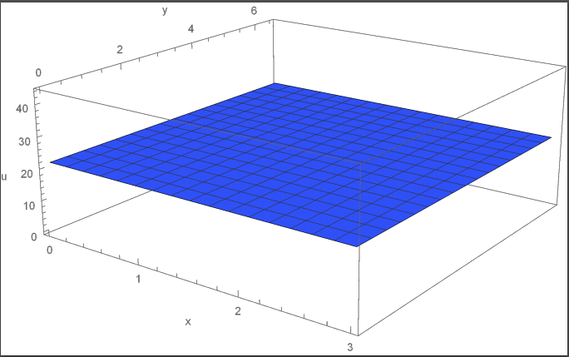
Fig. 1. Lower plane of the plate before heating. The temperature distribution at t = 0 was taken as constant throughout the entire area of ​​the plate with T = 22 °C.

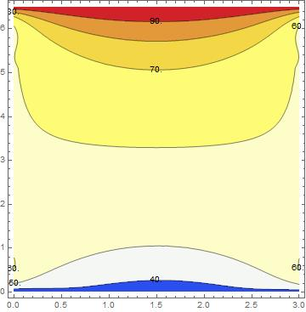
Fig. 2. Temperature distribution (Analytial approach). Distribution of temperature at t = 800 s, using mathematical software wólfram. The temperature distribution is directly influenced by the boundary conditions.
For t = 800 (Fig.2), The influence of the heaters is apparent in the central where the temperature increases close to the zone of influence of the lateral and longitudinal heaters.
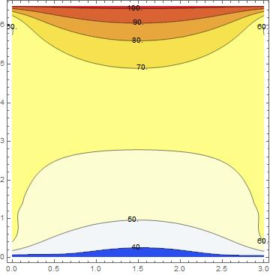
Fig.3 Temperature distribution (Analytial approach). Distribution of temperature at t = 2500 s.

For t = 2500 s (Fig.3), The temperature distribution in the plate is more uniform in the center, the boundary condition applied to the lateral edges promotes the formation of a soft function around the coldest zone of the plate, The behavior of the approximation to the analytic solution is shown in the following figure (fig.4):
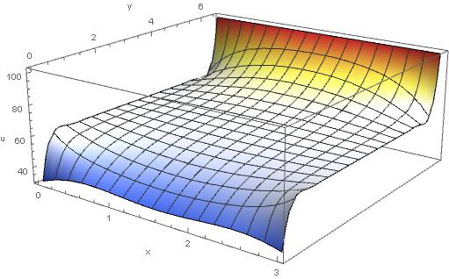
Fig.4 Temperature distribution function (Analytical approach). The coldest area (blue) is the one that is furthest from the effect of the heaters, the hottest zone (red) is near the heaters.
Proposal function:
For the proposed function, the temperature distribution at the bottom of the plate (Fig.5) Is uniform at t = 0, and as time progresses, the temperature tends to concentrate near the heater zone, until it is completely homogenized. t = 2500 s.
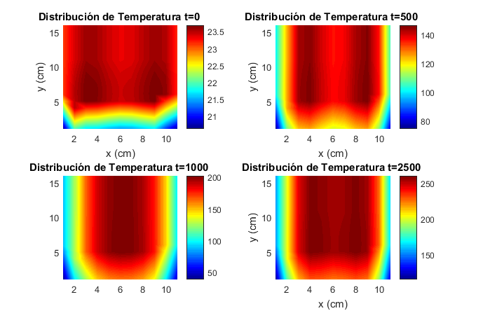
Fig.4 Temperature distribution at bottom of the plate (Proposal solution). Temperature distribution @t=0, 500, 1000 and 2500.

In the upper part of the plate (Fig.5), The temperature distribution behaves homogeneously from t = 500 s, this behavior is what is intended to have the plate in real condition.
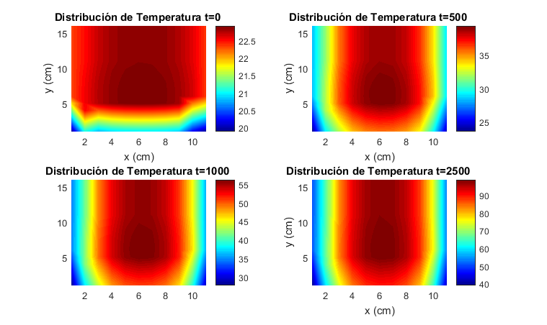
Fig.5 Temperature distribution at top plate (Proposal function). Temperature distribution @t=0, 500, 1000 and 2500.
CAE Software:
Simulation with NX software (Fig.6), 11234891 nodes of 0.1 mm spacing were evaluated along the plate with a processing time of 48.3 min. The Fluent solver was used with CFD controlled meshing, and a temperature on the top plate of 98 º C was obtained near the area of ​​greatest effect of the heater and 35.2 º C in the farthest area from the plate.
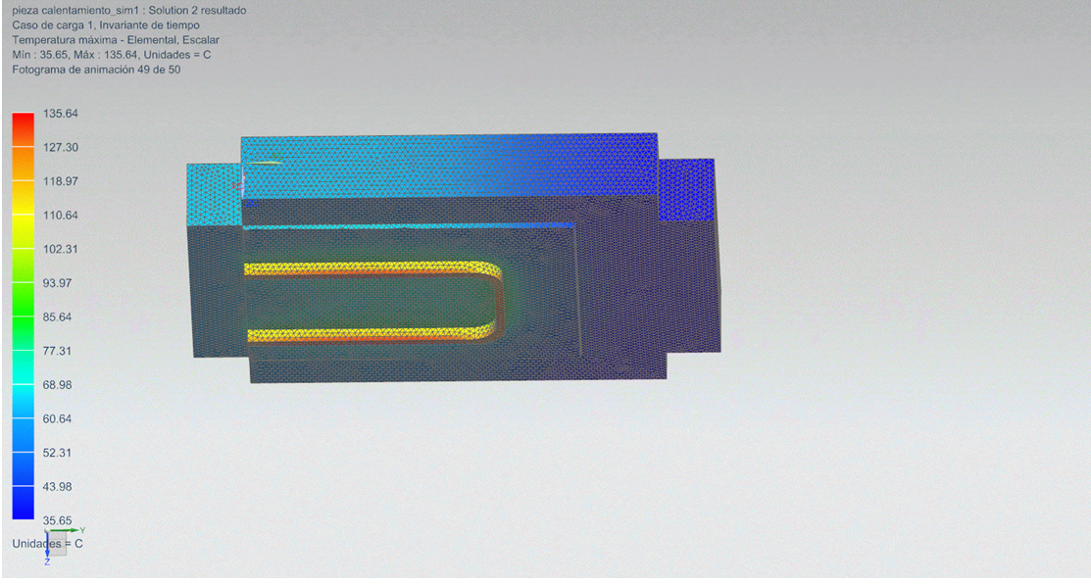
Fig.6 Temperature nodal distribution (NX Software). Temperature distribution @t=2500. Using fluent solver and cfd meshing.

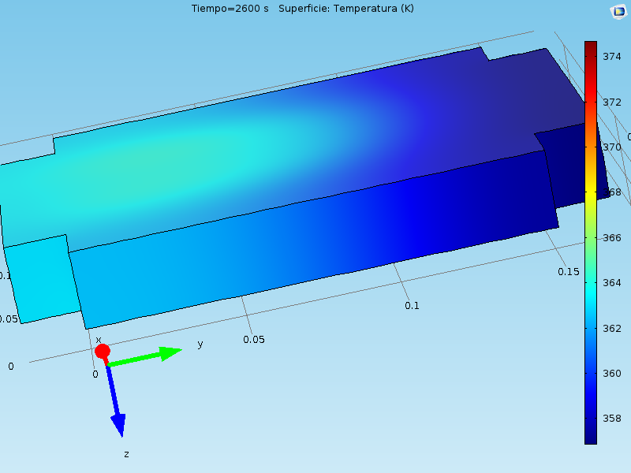
With the Comsol software (145298 nodes, 63.2 min) (Fig.7), The temperature distribution is similar to that shown with the NX software. The highest temperature shown by the software is 100.35 ° C and the lowest is the least affected area and has a temperature of 43 ° C.

Fig.7 Temperature nodal distribution (Comsol Software). Temperature distribution @t=2500. Using fluent solver and cfd meshing.
Correlation:
The hottest point in the plate was evaluated (Fig,1) to verify the similarity between the applied methods, the evaluated relation is against the real conditions (Table. 1).
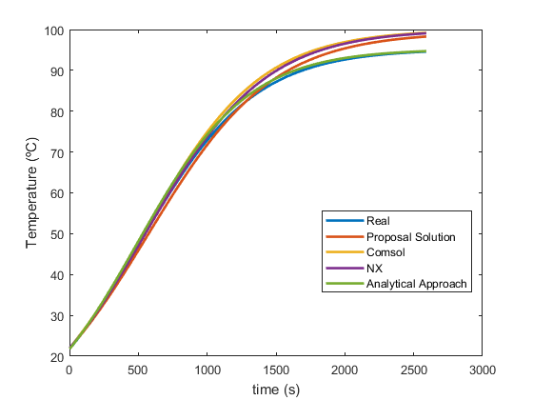
Fig.8 T(t) graphic function comparation. Temperature at the hottest poin of the plate for every method evaluation.

Table 1. Correlation between the proposed methods for solving the problem of temperature distribution in the upper part of the plate.
 | Real
Function | R2 | R adjust
Analytical approach | 0.93 | 0.91
Proposal function | 0.92 | 0.903
Comsol | 0.97 | 0.96
NX | 0.97 | 0.95

DISCUSSION

The distribution of temperature is shown to be uniform as time progresses in real conditions, however, in most of the heating stage, the T (t) graphs disagree, which may be due to the fact that boundary conditions require adjustment or a softer function should be proposed. The correlation indexes are satisfactory for the study performed, the approximations made by a proposed function and the approximation to the analytical solution show satisfactory results regarding the hottest point of the plate, however, the established boundary conditions still require adjustment to adapt to the ideal behavior of the phenomenon in real conditions.
The analytical solution presents a good correlation index as well as the proposed function, however, it is easier to perform calculations with the proposed function, than with the approximation function, because the coefficients of the equations obtained by the variable method separable, they make the calculation work increase considerably when the variables of thickness and time are added.
The simulation softwares offered satisfactory results, the data with which the software was fed were enough to achieve the satisfactory response of the phenomenon and can be used to predict the behavior under real conditions. However, they require many computer resource to perform the calculations of the temperature distribution and may lead to overheating of equipment that is not suitable for calculation.

CONCLUSIONS

The proposed solution will compete against the solution softwares and the approximations to the analytical solution, it’s essential to be very careful in defining the initial and frontier conditions.

Also, it’s necessary to carry out the experimentation in initial conditions to be able to have more detail of the behavior of the borders, in this way, the transfer functions that are proposed will be more effective to understand the phenomenon.

The simulation softwares give a clearer idea of ​​the temperature distribution along the plate, its crucial to take special care in the data with which it is fed to have clear reliability of the results.

The next step is to submit the fabricated device to convective fluids with Reynolds numbers near the state of transition and forced convection, to evaluate the temperature distribution under operating conditions of the bioreactor.

FUNDING AND ACKNOWLEDGMENTS

List only the funding agencies and any associated grants or Project numbers, as shown in the example below:
National Science Foundation (NSF) (1263235, 0968895, 1102301); the 863 Program (2013AA014402).
The acknowledgments may contain information not related to funding:
The authors thank H. Haase, C. Wiede, and J. Gabler for technical support.
Do not use Funding Information or Acknowledgment headings.
REFERENCES

1)Arderius, J. C.1996. Experimental-numerical determination of thermal coefficients through a phase-change process. Int. Comm. in Heat and Mass Transfer, 23:745-754. doi:10.1016/0735-1933(96)00057-7
2)Cattaneo, C. 1958. A form of heat conduction equation wich eliminates the paradox of instantaneous propagation. Comp Rend, 247:431-433. doi: 10.1155/2009/604695
3)Ferrando, R., & Spadacini, R. 1993. Approximate analytical solution of the jump rate problem in a symmetric well with spatially varying friction. Physica A: Statistical Mechanics and its Applications, 196:83-92. doi: 10.1016/0378-4371(93)90084-H
4)James, H. E. 1995. Chemical Kinetics and Reaction Mechanisms.2nd Ed. Iowa: McGraw-Hill. ISBN: 9780080550503
5)Lienhard, John, L. 2000. A Heat Transfer Textbook. 3rd Ed. Cambridge, MA. University of Houston.
6)Mason, I. 2006. Mathematical Modelling of the Composting Process: a Review. Waste Manage, 28:1375-1385. doi: 10.1016/j.wasman.2005.01.021
7)Mitchell, A. D., & Krieger, N. 2006. Solid-State Fermentation Bioreactors: Fundamentals of Design and Operation. New York: Springer Science & Business. ISBN:1034540312854
8)Nutaro, J. J. 2011. Building software for Simulation. New Jersey: John Wiley & Sons. ISBN:9780470414699
9)Rodwell, W. V. 2015. Harper Bioquimica Ilustrada. Mc Graw Hill. ISBN:9786071509147
10)Rudakov, V. 1997. Analitycal solution of the diffusion equation for an instantaneous plane source at constant temperature gradient. Int. Comm. Heat Mass Transfer, 40:597-585. doi: 10.1016/S0017-9310(96)00243-8
11)Vermotte, P. 1958. Les paradoxes de la theorie continue de lequation de la chaleur. Comp Rend, 246:3154-3155.
12) Zumdahl, Steven J. 2014. Chemistry 9th Ed. Brooks Cole. ISBN: 9781133611097

